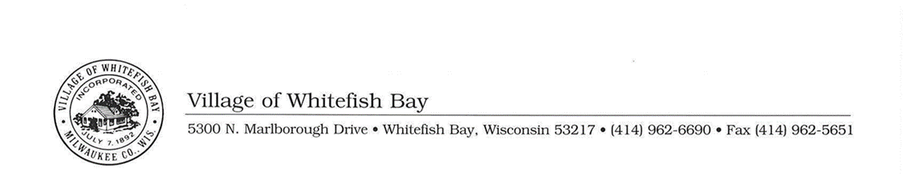
Water Supply Service Area Plan
The North Shore Water Commission (NSWC) has enlisted the services of Donohue & Associates to draft the Commission's Water Supply Service Area Plan. This is a planning document required by Wis. Stat. s. 281.348 for communities to document that a public water supply system (which serves a population of 10,000 or more) can supply an adequate and sustainable amount of water. As a general planning document the goal is to provide basic information about the Commission’s future plans to the public or oversight boards.
Draft NSWC Water Supply Plan
DNR Factsheet - NR 854
DNR Presentation Slides - NR 854
Anyone with comments on the NSWC’s draft Water Supply Service Area Plan should submit them by December 3, 2025 to the Plant Manager at NSWC, at manager@northshorewc.com or by calling 414-963-0160 (leave a message if needed). The Commission will hold a public hearing on the draft Water Supply Service Area Plan at their monthly meeting on December 10, 2025.

